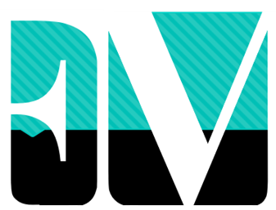2023 Functional Materials Conference and NSTC Project Seminar – STUST ChME | Date : 2023/6/2

Title
Firstname Lastname ¹, Firstname Lastname ² and Firstname Lastname ²*
¹Affiliation
²Affiliation
*Correspondence: email@email.com
Please indicate the NSTC project number

Abstract
- This seminar does not need to submit the full text of the paper, only the abstract of the paper.
- The format of the abstract is not limited. It can be written according to the abstract, introduction, experimental method, results and discussion, conclusion, references, etc., or provide a short abstract; but it should not exceed four pages. Please remember to select the report type below.
- The English font is Times New Roman, 10pt, and the line spacing is single line spacing. Graphical descriptions can be added as needed.
- If you sign up for the English oral competition, you must submit an English abstract

References
The font is Times New Roman, 10pt, single space.

Presentation type：
English oral competition ( inorganic materials, organic materials)
Poster competition ( inorganic materials, organic materials)
Exhibition only ( inorganic materials, organic materials)

